Codebasics SQL Challenge

# 1. Provide the list of markets in which customer "Atliq Exclusive" operates its business in the APAC region.

**SQL Querry:**

SELECT

distinct(market)

FROM dim_customer

WHERE customer = "Atliq Exclusive" and region = "APAC"

**Output:**

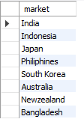

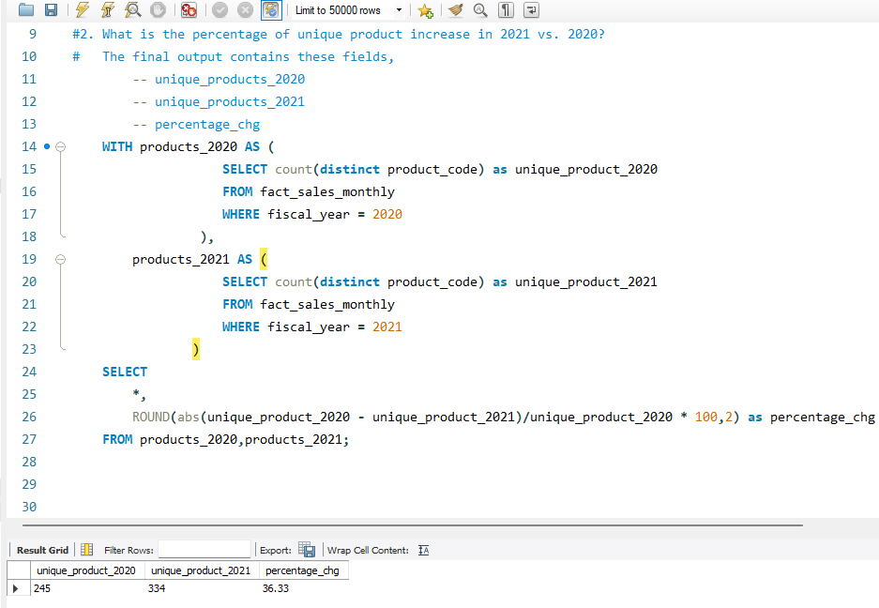

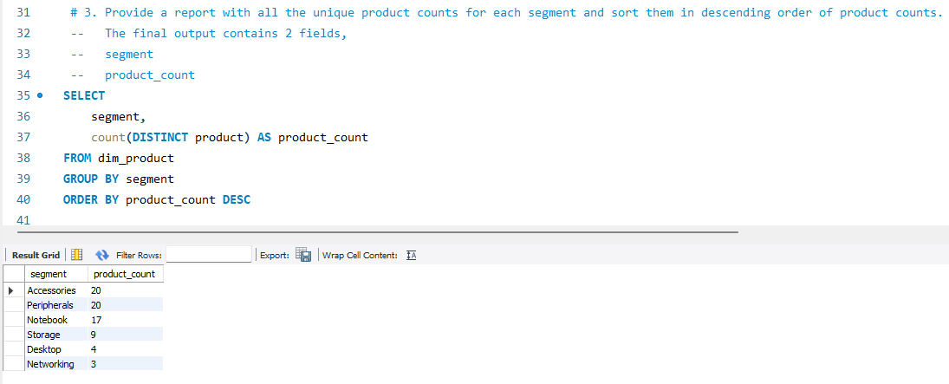

4: Which segment had the most increase in unique products in 2021 vs 2020?

-- The final output contains these fields, segment product_count_2020 product_count_2021 difference

SQL>>

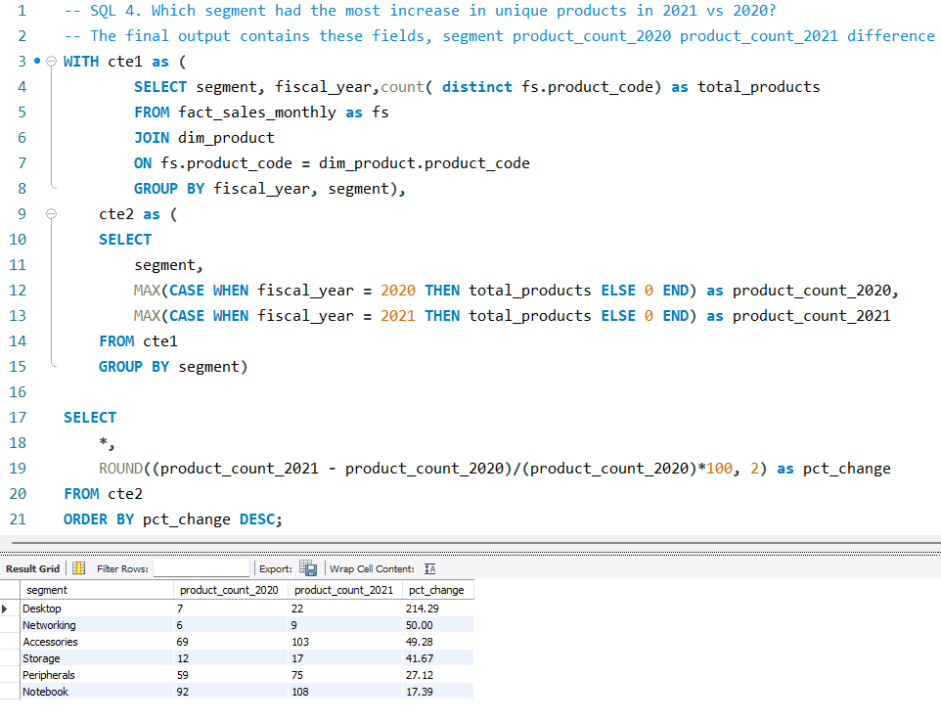

5.

SQL>>

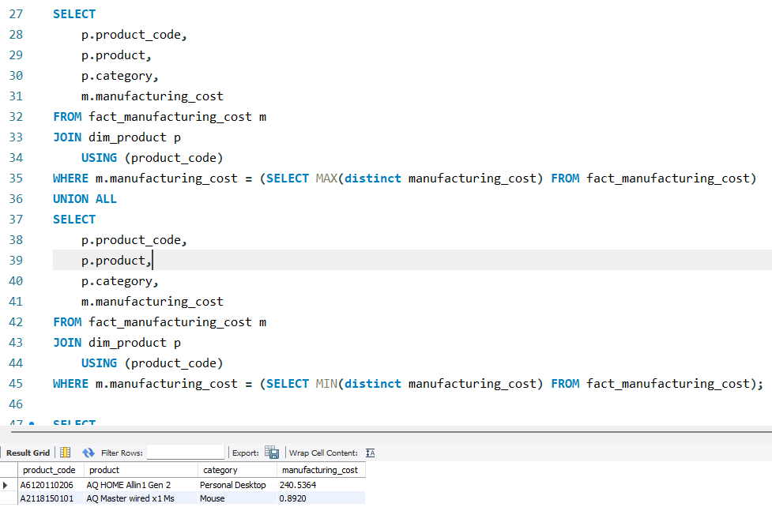

6. Generate a report which contains the top 5 customers who received an average high pre_invoice_discount_pct for the fiscal year 2021 and in the Indian market. The final output contains these fields, customer_code customer average_discount_percentage

SQL>>

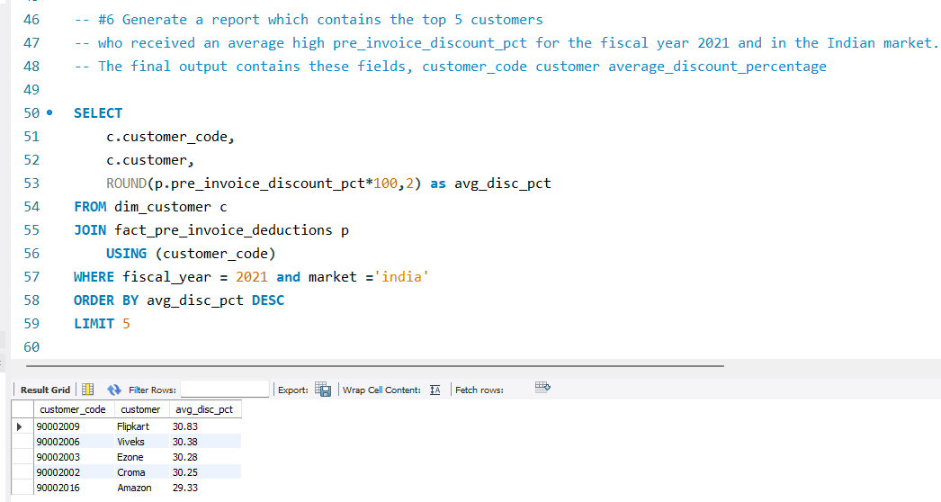

7. Get the complete report of the Gross sales amount for the customer “Atliq Exclusive” for each month.

-- This analysis helps to get an idea of low and high-performing months and take strategic decisions.

-- The final report contains these columns: Month Year Gross sales Amount

SQL>>

SELECT

CONCAT(monthname(date), " ", year(date)) as MonthYear,

year(date) as Year,

ROUND(SUM(s.sold_quantity * g.gross_price)/1000000, 2) as gross_sales_amount_in_millions

FROM fact_sales_monthly s

JOIN fact_gross_price g

USING(product_code, fiscal_year)

JOIN dim_customer c

USING (customer_code)

WHERE customer = "Atliq Exclusive"

GROUP BY MonthYear

ORDER BY Year asc